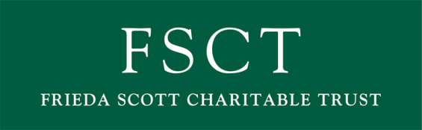

EVALUATION FORM

Grant No: /

As a Trust, we are vitally interested in whether our funding of your project made a difference to the people you serve. This form is a very simple way of gaining feedback about your successes, your difficulties and your learning. The learning is particularly important as we try to pass on the experiences of others to new projects and organisations that we support.

Please be frank in your answers to the following questions and don’t forget to send us a copy of your latest Accounts & Annual Report with this form. Any photos/visual images of your project would be very much appreciated either by post (address below) or digitally by e-mail to: celia@fcsct.org.uk Thank you

Organisation:

Date paid:

Grant awarded: £
Key contact:

Date:

Form completed by:

PROJECT – please describe the project/service/role this grant funded

BENEFICIARIES

- What were the needs of the people who benefited from this project/service/role?

- Please give a brief description of who was involved with the project

  - How many individual people benefited? ____

  - Their age was 0 – 5 yrs 6 - 19 yrs 20 – 60 yrs Over 60 yrs

  - Male Female

  - How many paid staff were directly involved? ____

  - How many volunteers were directly involved?____

  - Where were the majority of beneficiaries from?__________________ (e.g. Kendal etc)

%
%
%
%

%
%
%

IMPACT/OUTCOMES

- What did this project/service/role achieve - what difference have you made?

- Please describe any difficulties or setbacks you have experienced in carrying out this project/service/role?

CASE STUDY

Can you describe a person or situation that tells the story of the difference this grant has made?

FEEDBACK

- How could we improve our systems/procedures as a funder?

- Any other comments?

Thank you for taking the time to fill in this form. Please e-mail it back to us at celia@fcsct.org.uk or post to:

Celia Forsyth, Trust Secretary, Frieda Scott Charitable Trust Tel: 01539 742608
Stricklandgate House, 92 Stricklandgate, Kendal, Cumbria, LA9 4PU
Registered Charity no 221593

y/frs/general/logos/evaluation form April 12

